[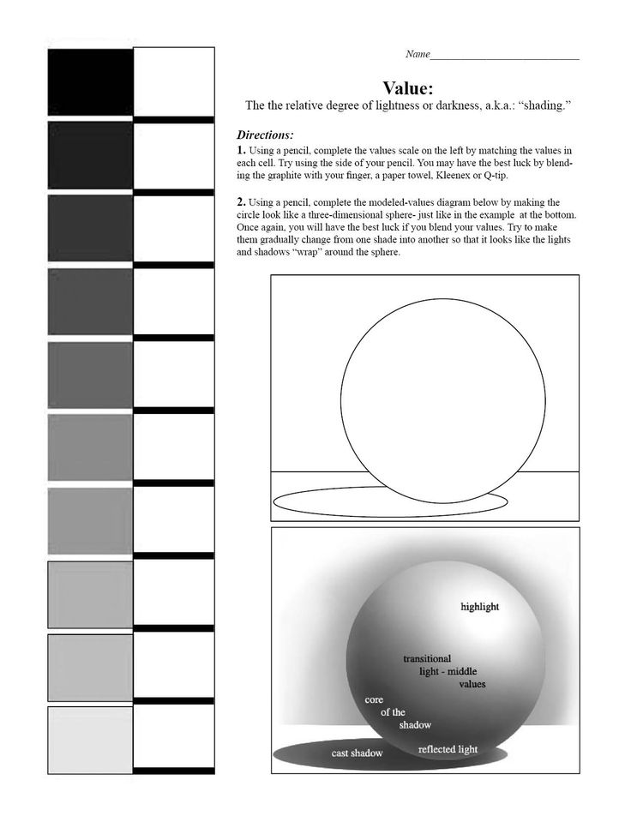](https://www.google.com/url?sa=i&rct=j&q=&esrc=s&source=images&cd=&cad=rja&uact=8&ved=0ahUKEwiyoqS-_OLRAhVJlVQKHQf_CG0QjRwIBw&url=https://www.pinterest.com/artsklgrlofdoom/art-lessons-in-value/&bvm=bv.145063293,bs.1,d.cGw&psig=AFQjCNGrbXOnv8OgMhXroiyoYP51yr3Lfw&ust=1485628738890991)