Form: form refers to a three-dimensional work of art, such as a sculpture or installation
Pencil Holders
The object could be anything (school appropriate) if it can hold a pencil
Parameters
- Sketch out 3 possible ideas
- Wedge the clay
- Clay cannot be solid
- Must be between ¼ and ½ inch thick
- No smaller than 4 inches
- No larger than 6 inches
- If enclosed make sure there is a hole the air can pass through
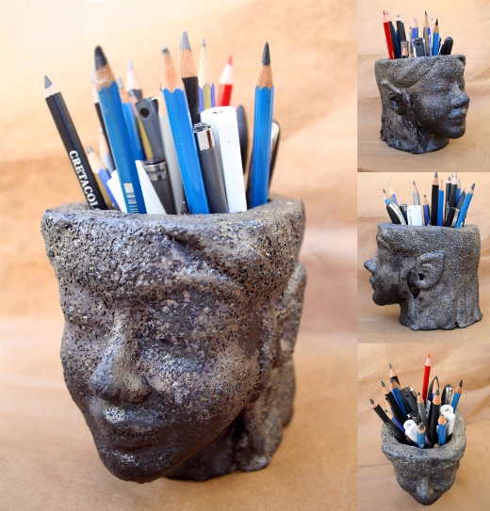
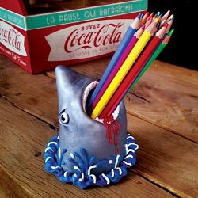
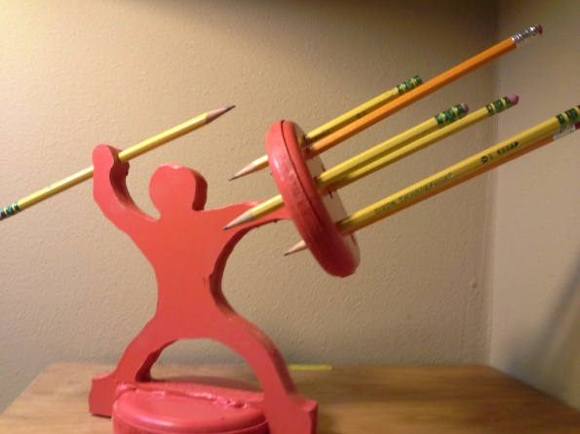
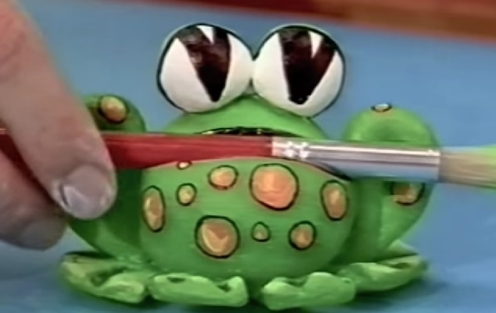
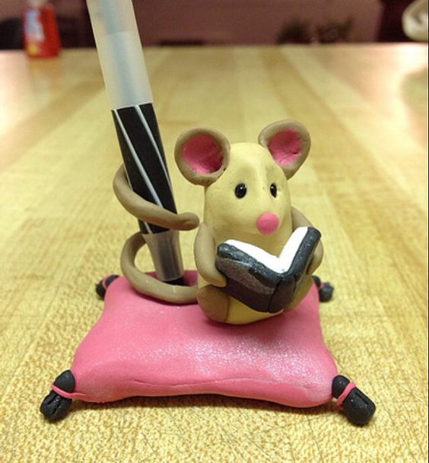
- Make it aesthetically pleasing (no lumps and bumps unless in the design)

